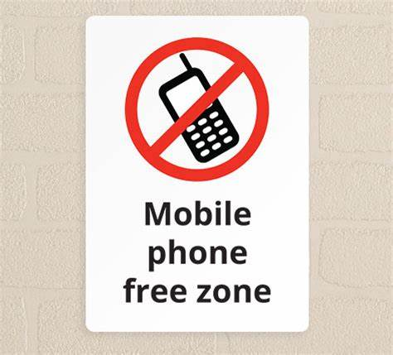

Parents/guardians/visitors
Our yard is a phone free zone this week
6th – 9th February 2024

